Litezupp – TR4A LED Kit

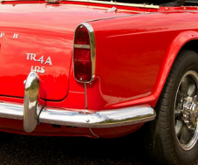
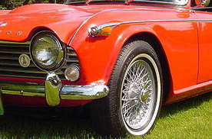

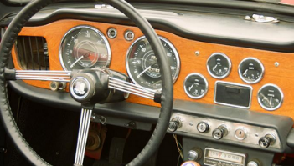

TR4A 12V systems
Function |  | Color | Industry # |  | Part # | Qty
Rear Brake/Run |  | Red | 1157 |  | L57RNP | 2
Rear turn |  | Red | 1156 |  | L56RNP | 2
Front Turn |  | White | 1156 |  | L56WNP | 2
Dash - Speedo/Tach Illum (2) (note 1) |  | White | 1446 |  | LDS12WNP-18DS | 1 PR
Dash – Gauges (4) (note 1, 2) |  | White | 1446 |  | LDS12WNP-18DS | 2 PR
Dash - Beam (1), Turn (1) |  | White | 1446 |  | LDS12WNP-18DS | 1 PR
Front Side marker |  | Amber | 194 |  | LDW12ANP-18DS | 1 PR
Front Running |  | White | 1895 |  | LDB12WNP-10CC | 1 PR
Rear License (note 2) |  | White | 67 |  | L56WN-mini | 2
Turn Flasher (negative ground) |  |  | 3 Term |  | LFM3NG-CG | 1
Part Number: TR4A LED Kit
- Contact us if you prefer a different color
- New wiring harness? Some dash lamps and License lamp may have changed. Let us know.
 | - Litezupp does not recommend replacing the IGN lamp with an LED
See our app note "Replacing IGN Lamp"
2021_12

